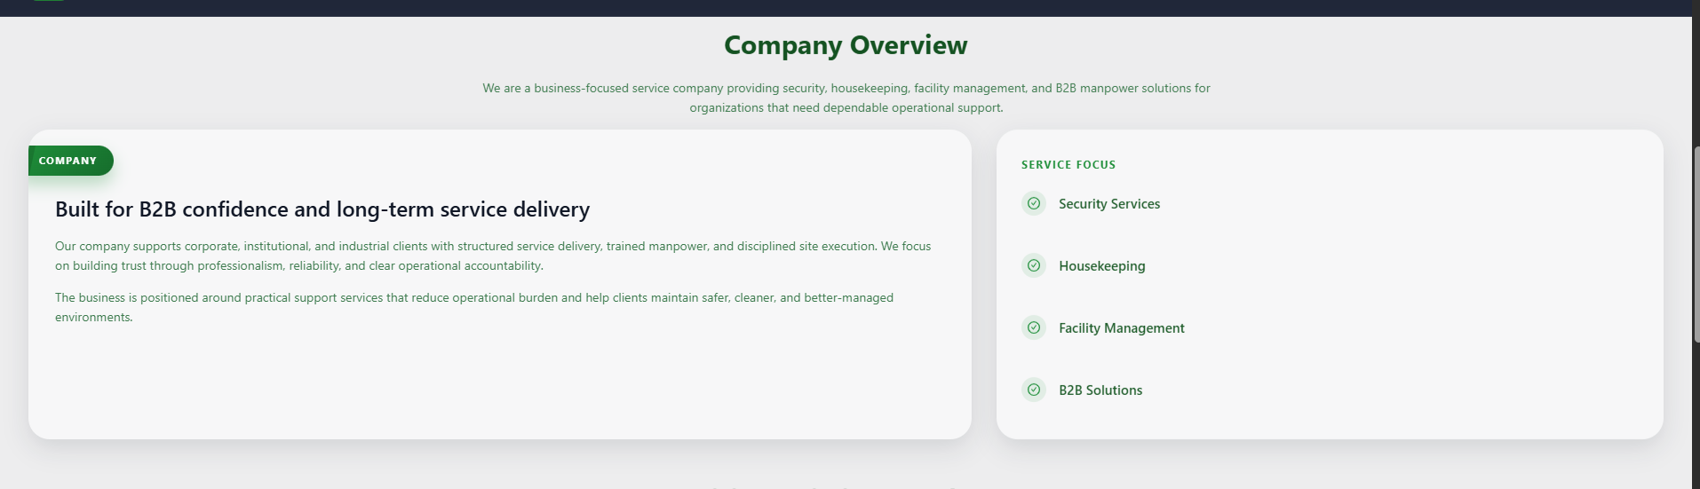
Built for Reliable Facility & Support Services Delivery
We are a business-focused service provider delivering facility management, housekeeping, security services, deep cleaning, and indoor gardening solutions to organizations that require dependable operational support.
Built on professionalism, reliability, and structured service delivery, we provide trained manpower and disciplined execution to ensure safe, clean, and well-maintained environments. Our services are designed to reduce operational burden and help clients maintain efficient and hygienic workplaces.

Service Focus
- Security Services
- Housekeeping
- Facility Management
- Deep Cleaning
- Indoor Gardening

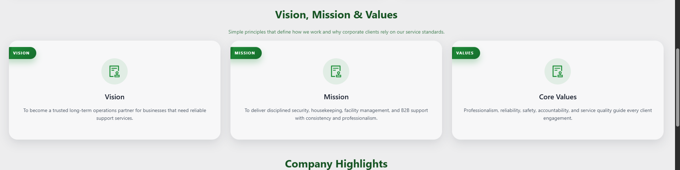

Vision
To be a trusted and preferred partner in delivering integrated facility management solutions, known for reliability, quality service, and long-term client relationships.

Mission
To provide efficient, safe, and high-quality facility management, housekeeping, security, deep cleaning, and indoor gardening services through trained manpower, structured processes, and a customer-focused approach—ensuring clean, secure, and well-maintained environments for every client.

Values
- Integrity – We operate with honesty, transparency, and accountability.
- Reliability – Consistent and dependable service delivery at all times.
- Quality – Commitment to high standards in every service we provide.
- Professionalism – Skilled workforce with disciplined execution.
- Customer Focus – Understanding and meeting client needs with care and responsiveness.
- Safety & Hygiene – Prioritizing safe and healthy environments in all operations.

Remove
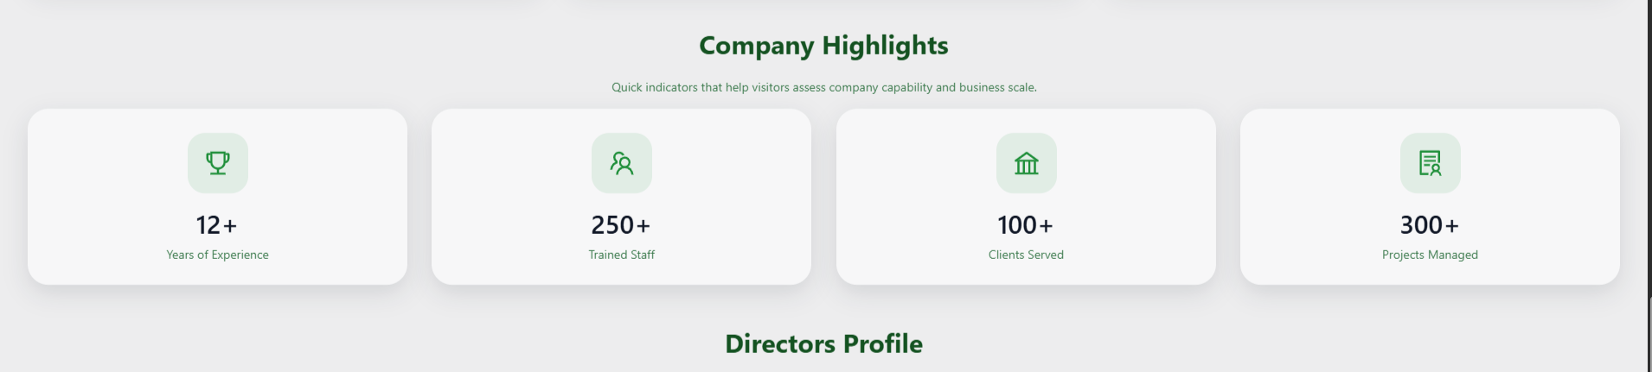
Remove
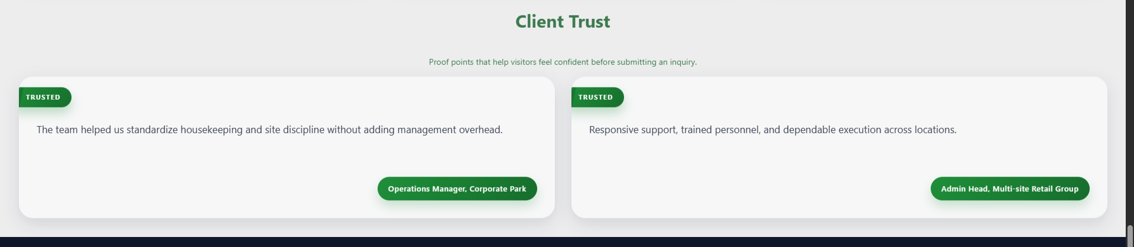

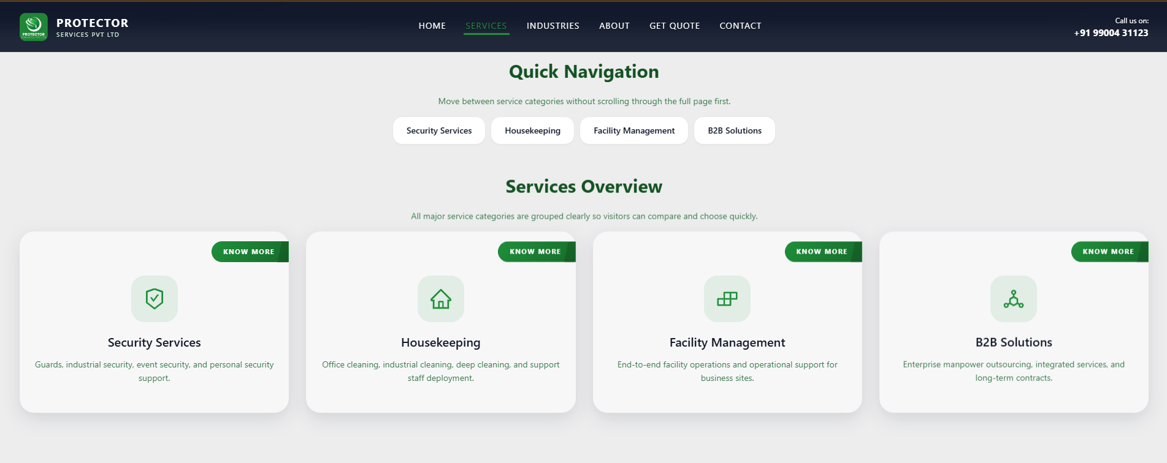

• Security Services
• Housekeeping
• Facility Management
• Deep Cleaning
• Indoor Gardening

